Informatics College Pokhara



Application Development

CS6004NA

Coursework 1

**Submitted By: Submitted To:**

Student Name:Amit ThapaMr. Ishwor Sapkota

London Met ID: 17030685 Application Development

Group: L3C1

Date: 10th-Jan-2019

**Table of Contents**

1. INTRODUCTION 4

1.1 Current Scenario 4

1.2 Proposed System 4

2. USER MANUAL 5

2.1 Login Screen 5

2.2 Main Window 6

2.3 Added Successfully 7

2.4 Report Window 8

2.5 Display Weekly Report 9

2.6 Display Chart 10

2.7 Student Detail Report 11

2.8 Enrolled Student List 12

2.9 Sort By Registration Date 13

2.10 Sort By Student Name 14

3. SYSTEM ARCHITECTURE 15

3.1 Architecture Diagram 15

3.2 Class Diagram 16

3.3 Flowchart for Student Enrollment 17

4. SORTING ALGORITHM 18

5. REFLECTION 19

6. CONCLUSION 20

7. BIBLIOGRAPHY 21

**TABLE OF FIGURE**

Figure 1:Login Screen 5

Figure 2:Main Screen 6

Figure 3:Added Successfully 7

Figure 4:Report Window 8

Figure 5: Display Weekly Report 9

Figure 6: Display chart 10

Figure 7: Student Detail Report 11

Figure 8: Enrolled Student List 12

Figure 9: Sorting by Registration Date 13

Figure 10: Sorting By Student Name 14

Figure 11: Architecture Diagram 15

Figure 12: Class Diagram 16

Figure 13: Flowchart 17

# INTRODUCTION

The Student Information System plays an important role in tracing the data and the personal information of the student. This system is designed to create and display the data according to the input in the graphical representation. The user must be able to input their data and the program must be able to display the weekly report on this basis. This can help user to sort the data in more easy and faster way which can be really helpful in educational institute. This system was designed in C# and must be able to perform the basic functions that are required to edit and add in the program. This will help user to get display the weekly report on the basis of different data like registration date, id, name and other similar data.

## Current Scenario

In the context of Nepal, we can be optimistic about the use of such system in different educational organization as everyone are trying to get more advanced. Different colleges and schools are trying to upgrade their system in more advanced way to store and handle the report of their student. As the competition is growing more and more the students will be attracted more towards such institute which are taking their system in more advanced way. So the use of such system has a bigger prospect in the current scenario.

## Proposed System

This system can help in lot of educational sector in today market. Now the system can be used to make data retrieve and display of the student in quick way. This will help to reduce the chance of error by the great margin as everything will now be in computer format. This will also make easier for the user to handle and search the information of student without any hassle.

# USER MANUAL

Screenshots are displayed below:

## Login Screen

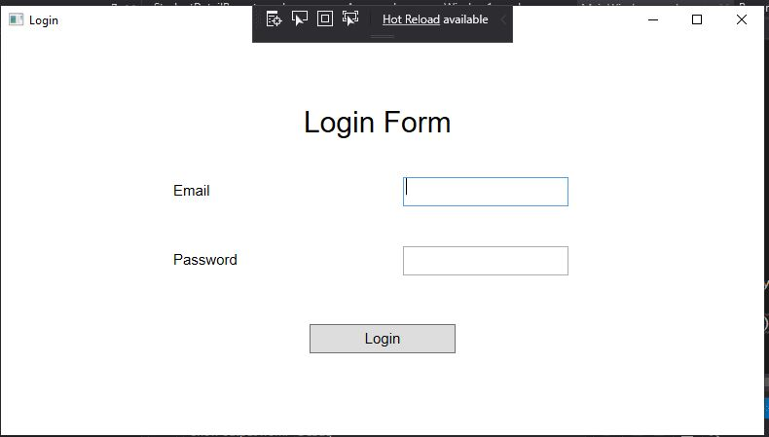

Figure :Login Screen

This section is where the user have to input their login user name and password to get access.

## Main Window

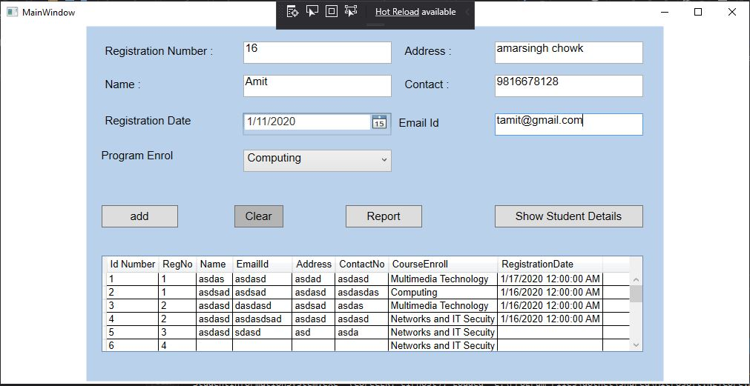

Figure :Main Screen

The main screen provides user to input basic details like registration number, name registration date , Page enroll, Address, Contact, Email Id and also allow to add clear and show the details like Report and Student Details.

## Added Successfully

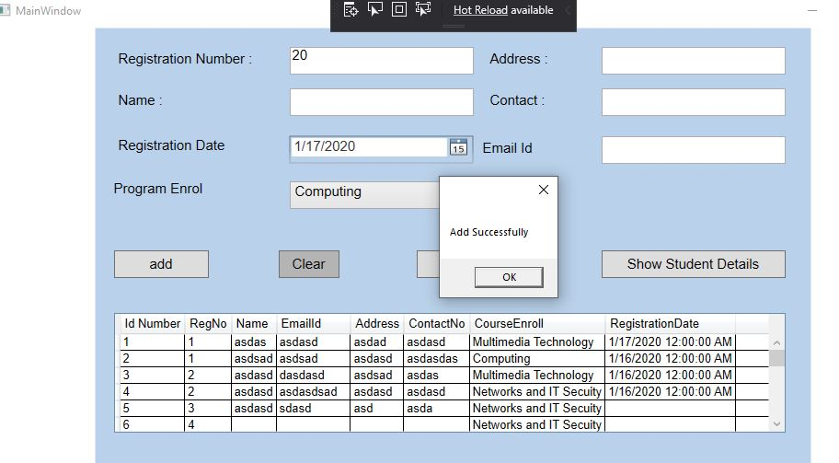

Figure :Added Successfully

After the data is added when the user click the add button above message which is add successfully will be shown.

## Report Window

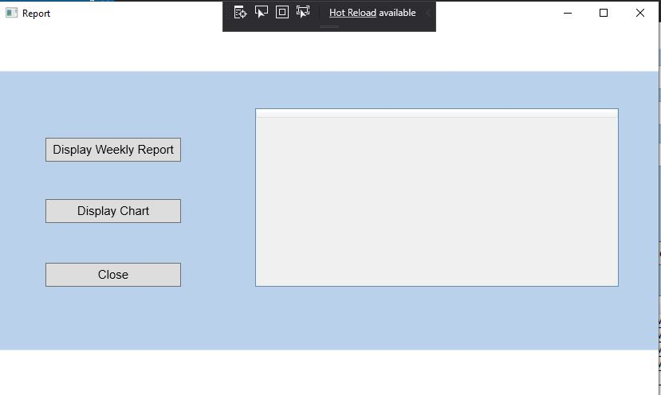

Figure :Report Window

After the main window operation is performed there is a report window button which clicked then the above window appears. In this window, we can see weekly report and chart.

## Display Weekly Report

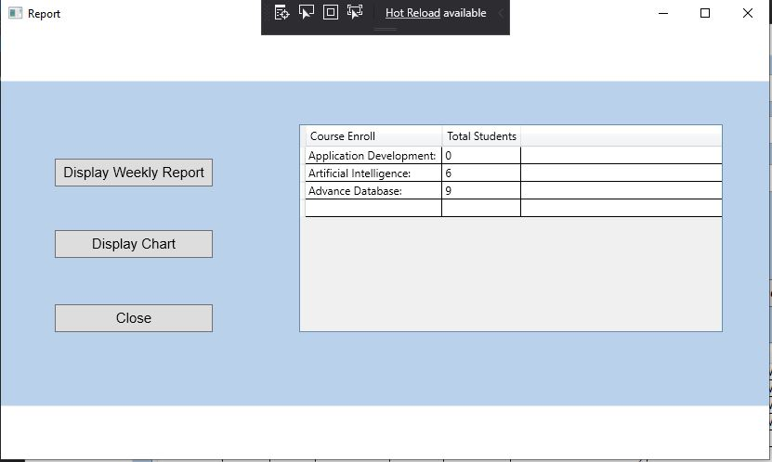

Figure :Display Weekly Report

In this section the weekly report is shown where we can see the total number of students that has been enrolled in the courses.

## Display Chart

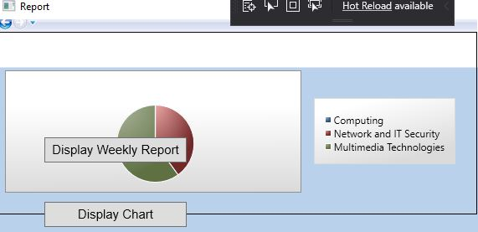

Figure :Display chart

In this section we can see the chart that has been displayed which contains the courses.

## Student Detail Report

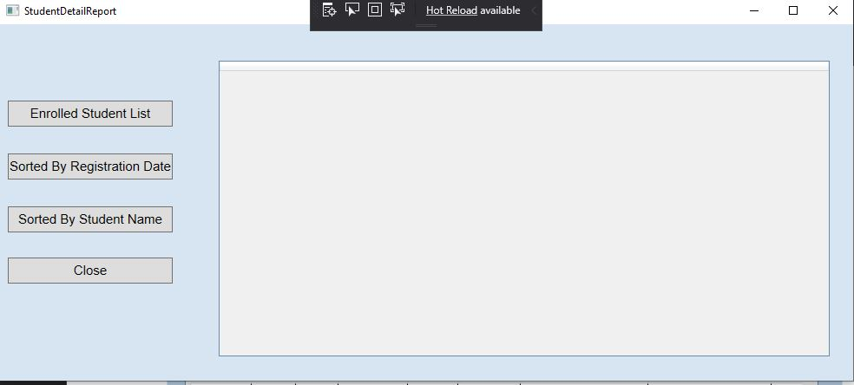

Figure :Student Detail Report

This is just the main window for Student Detail Report which contains the section like enrolling the student, sorting by registration date and sorting by student name.

## Enrolled Student List

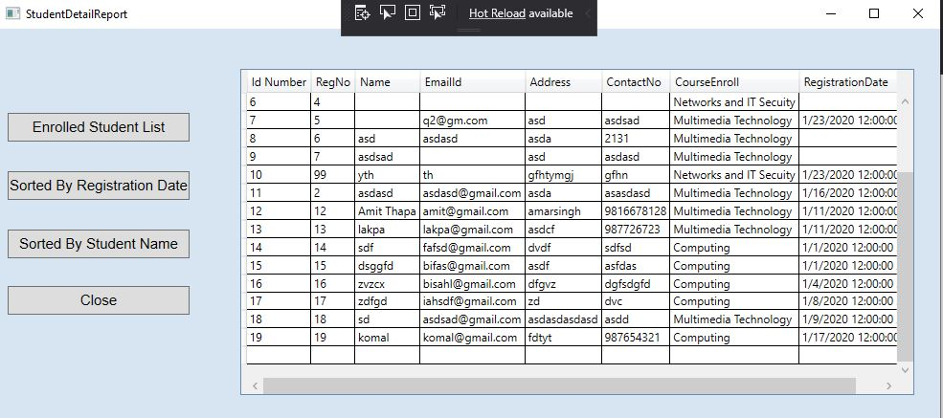

Figure :Enrolled Student List

In this window which is the section for enrolled student list we can see the number of student that has been enrolled. It also contains all the basic details of the enrollment of student and also other details like registration date.

## Sort By Registration Date

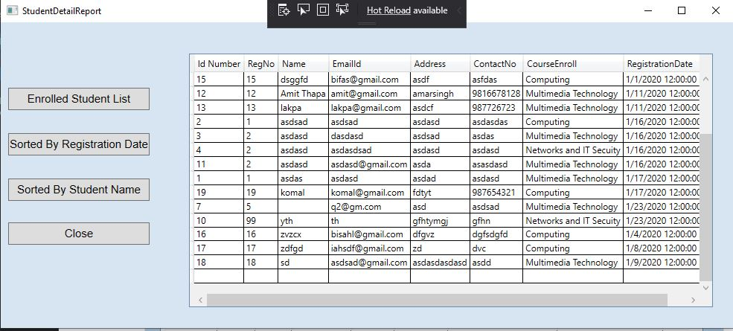

Figure :Sorting by Registration Date

In this section we can see the total number of student that has been enrolled with the basic details provided as below.

## Sort By Student Name

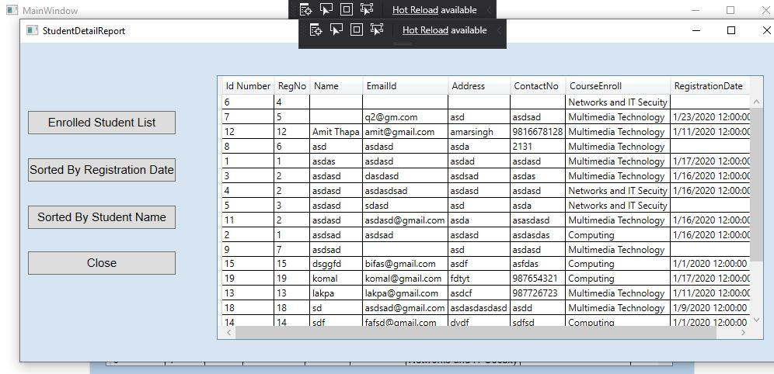

Figure :Sorting By Student Name

In this window the details are shown according to the sorting of student name.

# SYSTEM ARCHITECTURE

## Architecture Diagram

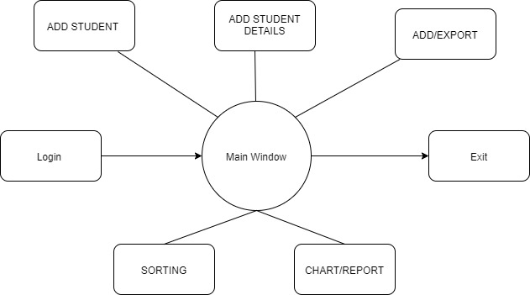

Figure : Architecture Diagram

## Class Diagram

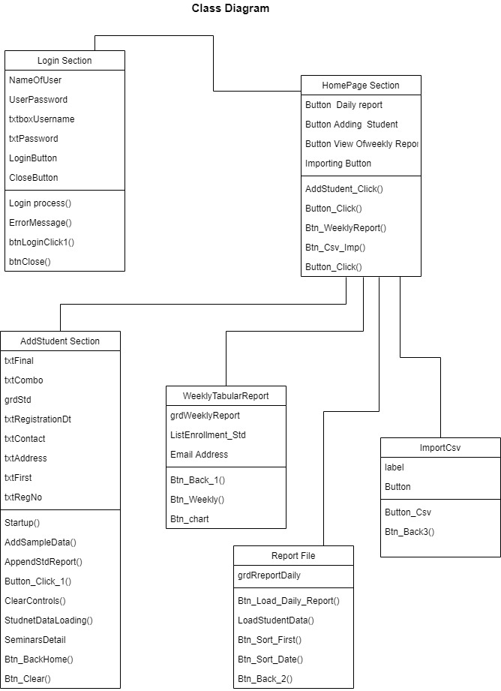

Figure : Class Diagram

## Flowchart for Student Enrollment

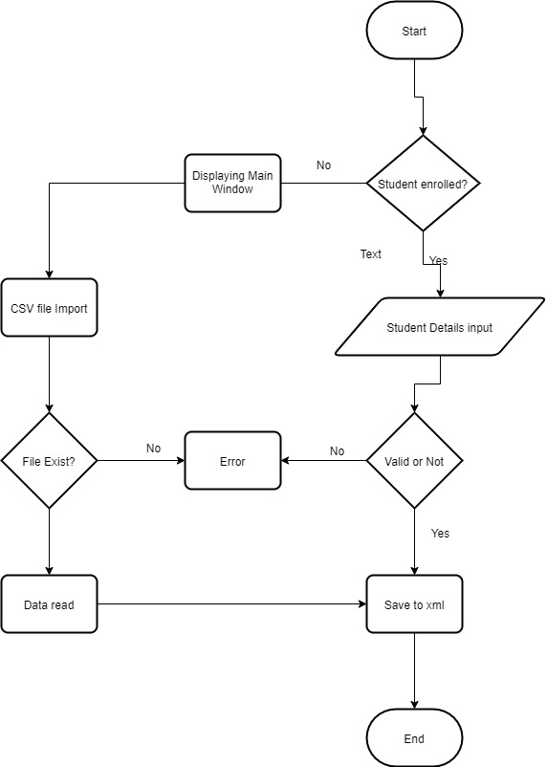

Figure : Flowchart

# SORTING ALGORITHM

Bubble Sort algorithm is what I have used in this system. This an easy set of rules that is used to type a given set of n factors supplied in shape of an array with n quantity of elements. Bubble Sort compares all the detail one through one and kind them primarily based on their values.

If the given array has to be taken care of in ascending order, then bubble type will start by evaluating the first detail of the array with the second one element, if the first element is more than the second element, it will swap each the factors, and then move on to compare the second and the third element, and so on. If we have overall n factors, then we need to copy this process for n-1 times. It is known as bubble type, due to the fact with every entire iteration the biggest detail within the given array, bubbles up toward the last place or the very best index, just like a water bubble rises up to the water surface.

Sorting takes area by way of stepping through all the factors one-via-one and comparing it with the adjoining detail and swapping them if required(www.studytonight.com/, n.d.).

# REFLECTION

The developed system referred as Student Information System is designed in Visual studio with the help of C#. The main idea behind the system is to create an environment here the data of the student can be stored successfully and shown in the form of report whenever it is necessary. This data can be stored in any sort of numbers and will be shown to the user in the form of chart which makes clear about the functionalities and the pattern of display. For example if a user wants to get the data in the form of sorting like sorting by name then he/ she can choose that way for data to be displayed. Similarly, the system is also designed to produce a chart which can make the user clear about the total percentage in more vivid way. The system will also be able to display the registration date which make user clear about the date of registration and also the user will be able to sort the data in any form of required result. This system will be able to display the any sort of error whichcan be like not entering the certain field or putting different kind of string in the able. This will help to prevent any kind of error that can take place in the future with wrong entry of data. So overall this system is a complete package to run and operate the student information system.

# CONCLUSION

In a nutshell, this project taught us to successfully build the system that can input the different data from the user and display it accordingly in the desktop form. This system will be great beneficial in the future market as it can handle a lot of data and input with much ease. After the completion of this project now an individual can have a confident to handle any sort of similar system development that is given to him/her. To complete the project we had to visit different websites to learn more about desktop app and also C#. Through this experience we learnt more about data handling and different steps to import and sorting data in visual studio. So in conclusion this project helped me as an individual to prepare the similar system in the future in much better way.

# BIBLIOGRAPHY

www.studytonight.com/, n.d. *StudyTonight.* [Online]   
Available at: https://www.studytonight.com/data-structures/bubble-sort  
[Accessed 1 Jan 2020].